Trees: Introduction

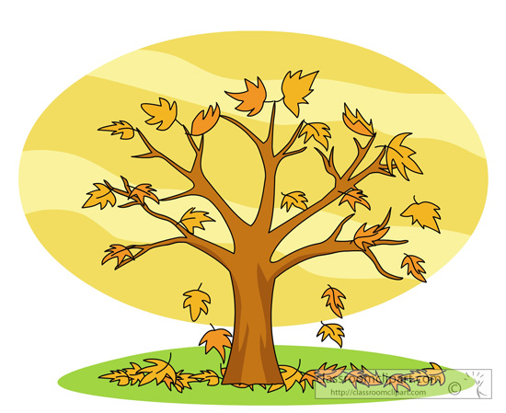
In computer science, a tree is a non-linear data structure in which each item can have many successors and all items, except the root, have exactly one predecessor.

Some real-world examples of tree structures include oak trees, a sentence parse tree, a family tree, and the organization of directories and files on your computer’s hard drive. Notice that computer science trees are drawn with the root at the top.

Sentence

Noun phrase Verb phrase

Article Noun Verb Noun phrase Prepositional Phrase

The girl hit Article Noun Preposition Noun Phrase

the ball with Article Noun

a bat

54
9
2
1
3
7
2

Definitions

Node | An item of data stored in a tree.
Root | The node at the top of the tree; it is the only node without a parent.
Parent | The predecessor of a node; a node in a tree can have only one parent.
Child | The successor of a node.
Left child | In a binary tree, the node linked to the left of the parent.
Right child | In a binary tree, the node linked to the right of the parent.
Sibling | The children of a common parent.
Edge | The link that connects a parent to its child.
Path | The sequence of edges connecting nodes.
Path length | The number of edges in a path.
Leaf | A node that has no children.
Depth (or level) of a node | The number of nodes from the root to the node. The root is number 0.  The root’s child is 1.
Height of a tree | The longest path from the root to the bottom-most node.  The longest path happens to equal the depth of the bottom-most node.
Width of a tree | The longest path in the tree from leaf to leaf.
Subtree | A node which is viewed as the root of a new, smaller tree

Binary Tree Definitions
Binary tree | A tree in which each node has 0, 1, or (at most) 2 children
Balanced binary tree | A binary tree in which the depth to left and right are nearly equal.  A completely unbalanced binary tree is linear, so that every child is to the left (or to the right) of its parent.
Full binary tree | A binary tree in which every leaf has the same depth and every nonleaf has two children. A full binary tree contains the maximum number of nodes for its height.
Complete binary tree | A binary tree in which every level except the deepest contains as many nodes as possible, and at the deepest level, all the nodes are as far left as possible.
Expression Tree | A binary tree in which the leaves are numbers and the nonleaves are arithmetic operators (+, - ,*, /)
Binary Search Tree (BST) | A binary tree with the property that each node is greater than or equal to all its left children and less than or equal to all its right children.
Heap | A binary tree with the property that each node is less than or equal to its children
64
3
1
8
5
9
4
94
5
3
24
4
8
8
5
9
8
54
2
1
8
9
2

9

2
2

nearly balanced, BST linear, BST a binary tree, not a BST a min-heap
not complete not complete complete full and complete

Tree Traversals
Preorder traverse | Visit the root, traverse the left subtree, traverse the right subtree. | root-L-R
Inorder traverse | Traverse the left subtree, visit the root, traverse the right subtree. | L-root-R
Postorder traverse | Traverse the left subtree, traverse the right subtree, visit the root. | L-R-root
Level-order traverse | From left to right, across the tree. DBFACE
D4
B
A
F
C
E
D4
B
A
F
C
E
D4
B
A
F
C
E

Preorder traversal: DBACFE Inorder traversal: ABCDEF Postorder traversal: ACBEFD

